
How to review devices signed in to your Apple Account
https://cyberguardlab.com/blog/apple-account-devices-signed-in-review
Independent US household comparison site. Not the vendor. Paid links below may earn a commission. Confirm first-year price, renewal, device limit, and refund terms at checkout.
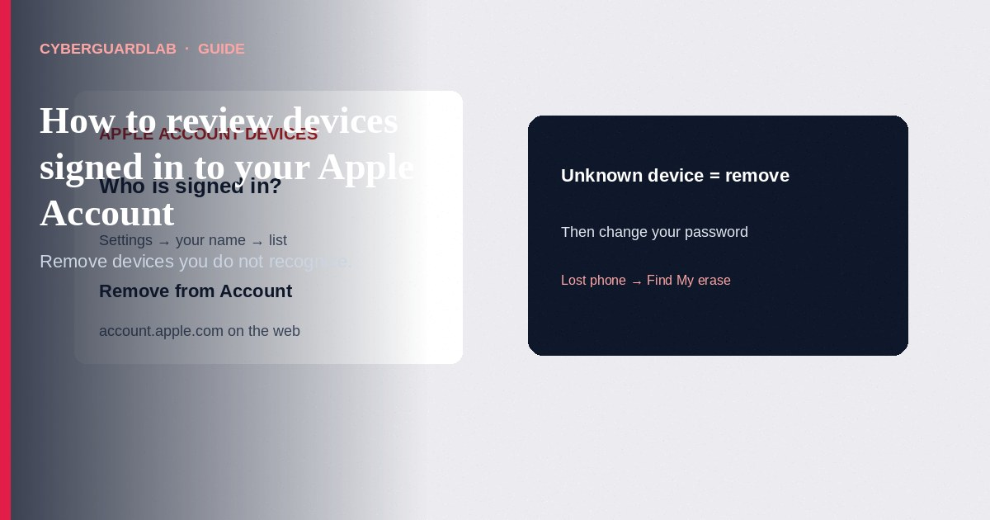
Reviewing devices signed in to your Apple Account means checking which phones, tablets, Macs, PCs, and streaming devices currently use your Apple Account—and removing any you do not recognize or no longer use. Apple Support explains that signing in adds a device to your list, where you can see trusted devices, sign out remotely, and stop unwanted access to iCloud and other Apple services. This guide focuses on Apple Account device list review (Settings, System Settings, and account.apple.com). It is not a Google Account device checkup and not a full Stolen Device Protection setup walkthrough.

Why the device list matters
- Devices on the list may be able to change your password, receive two-factor verification codes, edit personal information, or sync with iCloud—depending on device type.
- The list can include Android phones, Windows PCs, and streaming devices used with Apple Music or Apple TV—not only iPhone and Mac.
- Removing a device you do not use (or do not recognize) stops its access to iCloud, Find My, and other Apple services, and it will not show verification codes for two-factor authentication.
- If you stay signed in on a device and it reconnects to the internet, it can reappear—so permanent removal may require signing out on that device or erasing a lost device with Find My.

Red flags on the device list
Cue | Safer habit | Worry signal
Paid link
Norton 360 | See the Norton first-year offer

See the Norton first-year offer
Offer page: https://cyberguardlab.com/norton
Device name/model | Matches phones, tablets, Macs, TVs you own | Model or city/time you cannot explain
Old handset you sold | Signed out before sale; removed from list | Still listed weeks after you gifted or traded it in
Verification codes | Codes only go to devices you control | Unexpected “Apple Account” prompts on a device you do not have nearby
After a scam or shared login | Immediate device review + password change | Skipping the list after entering your password on a stranger’s Mac

Steps: review and remove Apple Account devices
- On iPhone or iPad — Open Settings → tap your name → scroll to the device list. Tap a device for model, serial, software version, and trusted-device status (you may need to authenticate).
- Remove an unwanted device — Tap Remove from Account, read the warning, and confirm.
- On Mac — Apple menu → System Settings → click your name → scroll to devices. Click a device to inspect; use Remove from Account if needed.
- On the web (Windows, Android, or no Apple device handy) — Sign in at account.apple.com, choose Devices, use View Details if asked to authenticate, then review or remove.
- If the device is lost — Do not only remove it from the list while it stays signed in. Use Find My to enable Lost Mode or erase the device remotely, per Apple’s lost-device guidance linked from the same support article.
- If it keeps coming back — Sign out of iCloud and related Apple services on that hardware, or erase it, so it cannot rejoin the list when it next reaches the internet.
- After removing strangers — Change your Apple Account password from a device you trust, confirm two-factor authentication and trusted phone numbers, and review recent account email alerts.

Safer Apple Account habits (buy-nothing)
- Review the device list after selling a phone, letting a repair shop sign in, or sharing a family Mac.
- Keep Stolen Device Protection and Find My on for iPhones you carry daily (see related guide).
- Use a unique password and reject unexpected “Apple Support” calls that ask you to share a verification code.
- Built-in Apple Account controls are the core fix; Microsoft Defender or other paid antivirus on a PC does not replace reviewing this list. Buy-nothing is valid.

FAQ

Will removing a device erase its photos?
Removing from Account signs that device out of Apple Account services remotely. Follow Apple’s prompts carefully. For a lost phone, prefer Find My Lost Mode / erase so your data stays protected.

I see a Windows PC or Android phone. Is that always a hack?
Not always. Apple notes those can appear when you use Apple Music, Apple TV, or other Apple Account services on non-Apple hardware. Remove it if you do not recognize the use.

How is this different from Google’s device list?
Same household idea, different account. Use Google’s Security Checkup for Google; use Apple’s device list for Apple Account access.

Someone stole my iPhone. Is Remove from Account enough?
Apple’s article points you to lost-device steps (Lost Mode / remote erase). Removing from the list alone may not be enough if the thief stays signed in until you erase or change credentials.

Do I need paid antivirus to secure my Apple Account device list?
No. Regular review, strong unique passwords, and Find My habits are enough for most households.

If you still want a paid suite
Reviewing Apple Account devices does not require paid antivirus. If you still want multi-device paid protection, use only these on-site links: Norton (paid link), Bitdefender (paid link), TotalAV (paid link), McAfee (paid link), Avast (paid link).

Extra caution
A device name that “almost” looks like yours still deserves a tap—check model and serial.

Sources
- Apple Support: Review devices signed in to your Apple Account
- Apple Support: Trusted phone numbers and trusted devices
- Apple Account (web)
- FTC: How to avoid a scam
- ReportFraud.ftc.gov

Also read
- Google unknown device logins
- iPhone Stolen Device Protection
- Is Microsoft Defender enough?
- Passkeys on Google, Apple, Microsoft
- Fake password-reset email
- Clicked a phishing link: first hour

