
How to use a work profile to isolate risky Android apps
https://cyberguardlab.com/blog/android-work-profile-isolate-apps
Independent US household comparison site. Not the vendor. Paid links below may earn a commission. Confirm first-year price, renewal, device limit, and refund terms at checkout.
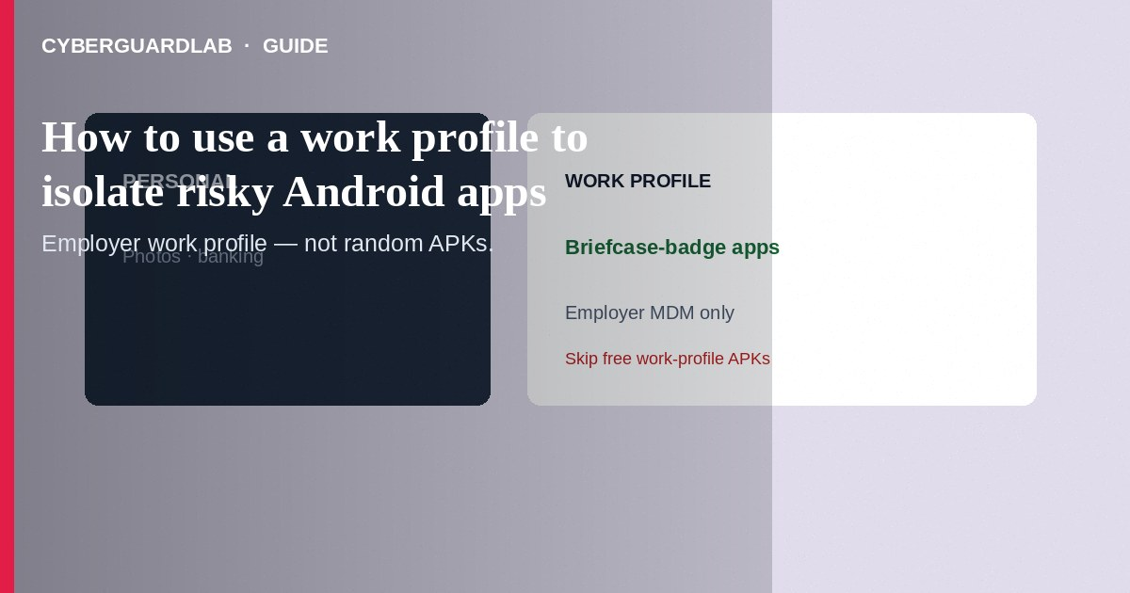
An Android work profile (managed profile) keeps work apps, accounts, and data in a separate badge-marked space from your personal profile—useful when IT enrolls your phone, and adaptable in spirit when you need isolation from risky sideloaded or “just testing” apps via employer MDM or carefully chosen personal tools. Use the work profile for corporate email/VPN apps; keep unknown APKs and experimental tools out of your primary profile when policy allows. This how-to is about work-profile isolation on Android—not Find My Device setup, not Chrome Enhanced Safe Browsing, and not Apple configuration profiles.

1. What a work profile does
Apps in the work profile get a briefcase badge. Notifications, storage, and accounts can be separated so a messy work app has a harder time freely mixing into personal photos and personal WhatsApp data. Your organization may control installs, remote wipe of the *work* side, and required PINs. Personal-profile wipe policies differ—read your employer’s mobility rules.
Paid link
Norton 360 | See the Norton first-year offer

See the Norton first-year offer
Offer page: https://cyberguardlab.com/norton
Apps that promise a work profile without your employer—especially outside Play Store—are often malware or phishing wrappers. Real work profiles come from organization enrollment or built-in OEM private-space features, not a random “Island clone” push from a text message.

2. Personal isolation when you lack corporate MDM
Approach | Isolation idea | Caveat
Employer work profile | Strong managed separation | IT can wipe work data; follow policy
Secondary user / private space (OEM) | Extra user or “Private space” for experiments | Features vary by Pixel/OEM; not identical to work profile
Separate cheap device | Hardware isolation for high-risk testing | Still enable Find My Device
iPhone config profile | Different platform mechanism | See Apple profile check—not Android work profile

3. Steps: use an employer work profile safely
- Enroll only through your IT instructions (QR, token, or managed Google account)—not through a cold-email “MDM enroll” link.
- After enrollment, open Settings → Accounts / Password & accounts and confirm a work profile section exists.
- Install work email, chat, and VPN only from the Work tab in Play Store (Managed Google Play) when your company uses it.
- Do not move risky personal sideloads into the work profile to “hide” them from IT—and do not install unknown APKs in the personal profile either.
- Use the work profile pause/off toggle (if offered) after hours so work apps stop notifying—without deleting the profile unless IT says to.
- If you leave the job, follow IT offboarding; they may remove the work profile remotely. Back up only what policy allows.
- Separately, review Google third-party app access on the Google Account used for personal Play.

4. Risky apps: practical rules
- Prefer Play Store over random APK sites. If you must test an APK, use a secondary user/private space or spare device—not your banking profile.
- Deny unnecessary mic/camera/SMS permissions; revoke in Settings → Apps.
- Keep Play Protect on; keep Chrome on Enhanced Safe Browsing for browser-borne lures.
- Windows companion PCs still need one antivirus primary: Norton, Bitdefender, or other on-site options (TotalAV, McAfee, Avast).

FAQ

Can IT read my personal profile through a work profile?
Design intent is separation, but device ownership, OEM, and MDM policy vary. Assume work devices and dual-use phones may have monitoring on the managed side—read your policy.

Is a work profile the same as a Google Account work login in Chrome?
No. Chrome profiles and Android work profiles are different layers.

Will a work profile stop Play billing phishing?
No. Phishing hits accounts regardless of profile—see fake Google Play billing.

Can I create a work profile without a company?
True Android Enterprise work profiles normally need a managed enrollment. For solo isolation, use OEM private space / secondary users or a spare phone rather than fake “MDM” apps from the internet.

If you still want a paid suite
Avoiding how to use a work profile to isolate risky Android apps does not require paid antivirus. Careful habits and official support paths are a valid buy-nothing stack. If you want multi-device paid protection later, use only these on-site paid links: TotalAV (paid link), Norton (paid link), Bitdefender (paid link), McAfee (paid link), Avast (paid link).

Sources
- Android Enterprise / work profile help (Google)
- Android Help: Find, secure, or erase (device readiness)
- Google Account third-party access
- FTC: Mobile security

Also read
- How to turn on Google Find My Device before you lose a phone
- How to review Google account third-party app access
- How to turn on enhanced Safe Browsing in Chrome
- How to check for configuration profiles on iPhone
- How to wipe a device before selling

