
How to turn on Private DNS on Android
https://cyberguardlab.com/blog/android-private-dns
Independent US household comparison site. Not the vendor. Paid links below may earn a commission. Confirm first-year price, renewal, device limit, and refund terms at checkout.
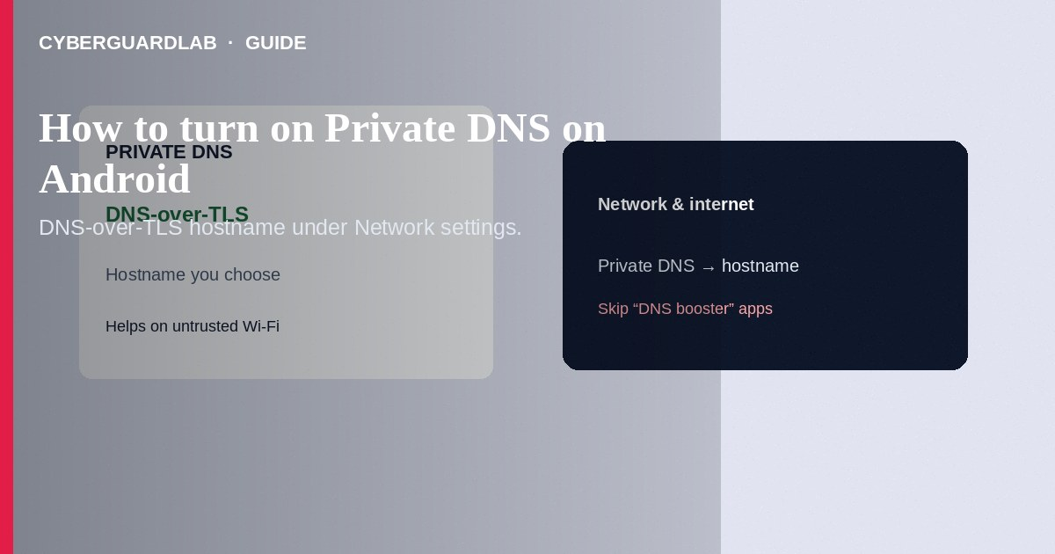
Android Private DNS sends DNS lookups over TLS (DNS-over-TLS) to a hostname you choose—helping stop casual network snooping and some DNS-based ads/malware redirects on untrusted Wi-Fi. Turn it on under Settings → Network & internet → Private DNS. This how-to is phone DNS encryption—not VLAN segmentation for TVs/cameras, not router admin password changes, and not WPA3 Wi-Fi encryption.

1. What Private DNS does and does not do
It encrypts DNS queries between your phone and the DNS provider. It does not encrypt all traffic (that is VPN/HTTPS), does not isolate IoT devices on your LAN, and does not replace antivirus or screen locks.
Paid link
Norton 360 | See the Norton first-year offer

See the Norton first-year offer
Offer page: https://cyberguardlab.com/norton
Apps that promise faster DNS while demanding Accessibility or Device Admin are malware bait. Use the system Private DNS toggle—not a sideloaded booster.

2. Private DNS vs other network controls
Control | Protects | Does not replace
Private DNS | DNS lookups from this Android device | Full-tunnel VPN, IoT VLAN, WPA3
VLAN for cameras | LAN isolation between device groups | Phone DNS settings
WPA3 / Wi-Fi password | Who joins your wireless | DNS privacy on cellular

3. Steps: turn on Private DNS
- Open Settings → Network & internet (on some OEMs: Connections → More connection settings).
- Tap Private DNS.
- Choose Automatic (uses DoT when the network supports it) or Private DNS provider hostname.
- If you pick a provider hostname, enter a provider you trust (examples commonly documented by public resolvers—verify spelling on the provider’s own site). Save.
- Browse a few sites. If the internet fails, switch back to Off or Automatic and re-check the hostname.
- Retest on cellular and Wi-Fi separately—some captive portals break until you temporarily set Private DNS Off.

4. Choosing a provider safely
- Prefer providers with clear privacy documentation you opened yourself—not a hostname from a random forum DM.
- Avoid “free DNS optimizer” APKs that ask for VPN permission—they are a different risk class (see fake 5G APK patterns).
- If you use a work MDM profile, ask IT before changing Private DNS—policy may override it.
- Keep Play Protect on; Private DNS is not malware removal. After a scare, still use Norton or Bitdefender on PCs in the home (TotalAV, McAfee, Avast on-site).

FAQ

Is Automatic enough?
Often yes for everyday use. A specific hostname helps when you want one resolver everywhere DoT works.

Why did hotel Wi-Fi stop working?
Captive login pages often need Private DNS Off until you authenticate, then you can turn it back on.

Is this the same as a VPN?
No. VPN tunnels more traffic to a VPN provider. Private DNS only wraps DNS.

Does Private DNS secure my smart TV?
No. Configure DNS or VLANs on the router/TV separately—see the VLAN guide.

If you still want a paid suite
Avoiding how to turn on Private DNS on Android does not require paid antivirus. Careful habits and official support paths are a valid buy-nothing stack. If you want multi-device paid protection later, use only these on-site paid links: TotalAV (paid link), Norton (paid link), Bitdefender (paid link), McAfee (paid link), Avast (paid link).

Sources
- Android Help: Manage advanced network settings (Private DNS)
- CISA: Securing DNS (general guidance)
- FTC: Secure your devices
- Google Public DNS (example DoT docs—verify before use)

Also read
- How to segment smart TVs and cameras on a separate VLAN
- How to turn on WPA3 or the strongest Wi-Fi encryption you have
- How to change your router admin password safely
- How to use banking apps on public Wi-Fi
- How to check if your home Wi-Fi is safe

