
How to back up an Android phone before a security wipe
https://cyberguardlab.com/blog/android-backup-before-security-wipe
Independent US household comparison site. Not the vendor. Paid links below may earn a commission. Confirm first-year price, renewal, device limit, and refund terms at checkout.
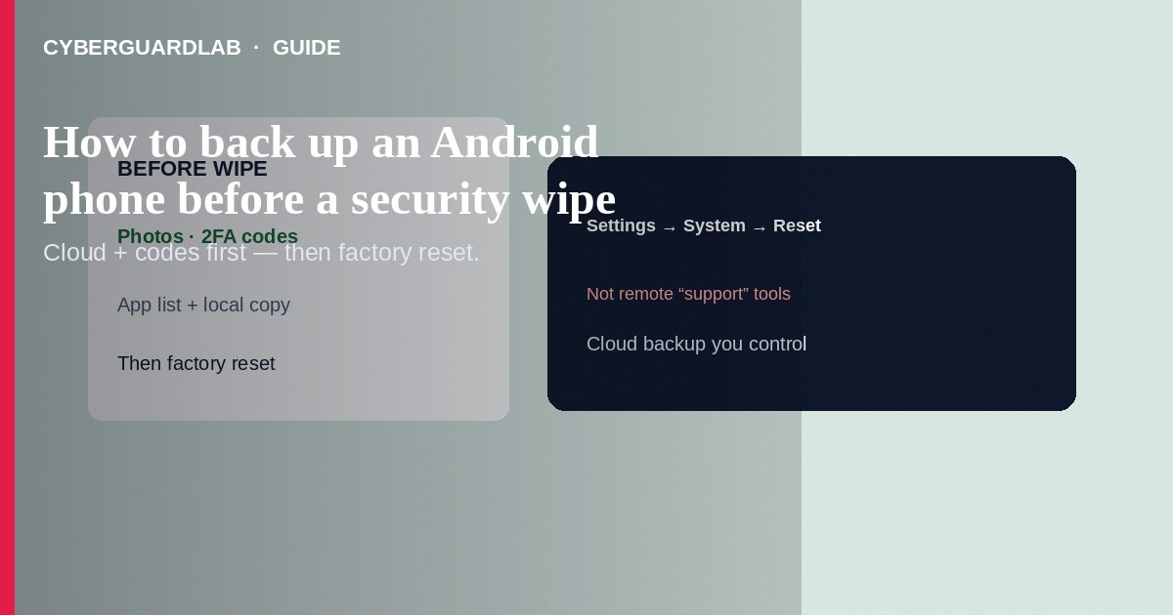
Before a security wipe (factory reset after malware or account takeover), back up photos, messages you still need, 2FA backup codes, and app lists—then reset from Settings → System → Reset, not from a stranger’s remote-support tool. Prefer cloud backups you control plus a quick local copy of irreplaceable files. This how-to is pre-wipe backup—not Private DNS, not Find My Device setup alone, and not the wipe steps for a phone you no longer hold.

1. What to capture before erase
- Photos/videos: Google Photos backup completed, or copy to a computer/SD card.
- 2FA: Export or write backup codes for authenticator apps; note hardware-key serials.
- SMS/call logs if your OEM or a trusted app still supports export (many do not—screenshot critical OTPs threads only if needed for fraud reports).
- WhatsApp/Signal: Use each app’s official chat backup flow before reset.
- Offline files: Downloads, documents, VPN profiles you still trust.
- App list: Screenshot Play Store library or note paid apps.
- SIM / eSIM: Know how to re-download eSIM from the carrier after wipe.
- Work profile: Ask IT before wiping a managed device.
Remote helpers who ask you to install AnyDesk before a “free malware cleanup” often steal banking sessions. Backup yourself, wipe yourself, then restore—no gift-card “verification.”
Paid link
Norton 360 | See the Norton first-year offer

See the Norton first-year offer
Offer page: https://cyberguardlab.com/norton

2. Backup vs wipe goals
Goal | Do this | Avoid
Keep memories | Photos + documents off-device | Skipping backup “to save time”
Remove malware | Factory reset after backup | Restoring a full rogue APK backup image from unknown USB
Account safety | New passwords + device review post-wipe | Reusing the same password the stealer already has

3. Steps: backup then security wipe
- Charge the phone above 50%. Connect to trusted Wi-Fi.
- Open Settings → Google → Backup (or System → Backup) and run backup; wait until it shows success.
- Confirm Google Photos and any OEM cloud backup finished.
- Copy irreplaceable folders to a PC or encrypted drive.
- Sign out of banking apps after you no longer need in-app access for dispute screenshots.
- Uninstall malware first if Android still allows—then proceed to wipe if infection persists.
- Settings → System → Reset options → Erase all data (factory reset). Confirm.
- After setup wizard, restore from the Google backup you created; reinstall apps from Play only.
- Change Google and important passwords from a clean browser if the wipe followed compromise.
- Re-enable Play Protect, screen lock, and Find My Device.

4. If malware blocked Settings
- Try Safe Mode (OEM power-menu variants differ) and uninstall the bad app, then backup and wipe.
- If the UI is locked, use android.com/find erase from another device when Find My Device was already on—accept that local-only files may be gone.
- Scan PCs that exchanged files with Norton or Bitdefender (TotalAV, McAfee, Avast on-site).

FAQ

Will Google Backup restore SMS?
Depends on Android version and OEM. Do not assume texts return—save fraud evidence first.

Is a full Titanium-style root backup safe after malware?
Risky. Prefer cloud app data + media, then clean Play reinstalls.

Should I wipe before or after changing the Google password?
If you still control a clean device, change the password first, then wipe the infected phone. If the phone is your only factor, use backup codes carefully.

Does this replace Advanced Protection?
No. Backup/wipe is incident response; APP is long-term hardening.

If you still want a paid suite
Avoiding how to back up an Android phone before a security wipe does not require paid antivirus. Careful habits and official support paths are a valid buy-nothing stack. If you want multi-device paid protection later, use only these on-site paid links: TotalAV (paid link), Norton (paid link), Bitdefender (paid link), McAfee (paid link), Avast (paid link).

Sources
- Android Help: Back up or restore
- Android Help: Factory reset
- CISA: Malware basics
- FTC: Malware

Also read
- How to spot a fake carrier 5G upgrade malware APK
- How to wipe a device before selling
- How to turn on Google Find My Device before you lose a phone
- How to turn on Private DNS on Android
- How to use a work profile to isolate risky Android apps

