
How to spot a fake Amazon Prime renewal scam
Read online: https://cyberguardlab.com/blog/amazon-prime-renewal-scam
Published September 27, 2026 · Updated September 27, 2026
Short answer
Ignore the renew / dispute link in an unexpected “Prime expires” or “unusual Amazon charge” message; verify only at amazon.com or the official Amazon app you open yourself; never enter your Amazon password or card on a cold page.
Advertising disclosure: CyberGuardLab is an independent comparison site. We are not TotalAV, Norton, Bitdefender, McAfee, or Avast. If you buy through our links, we may earn a commission, which can affect ranking and placement.
Independent US household comparison site. Not the vendor. Paid links below may earn a commission. Confirm first-year price, renewal, device limit, and refund terms at checkout.
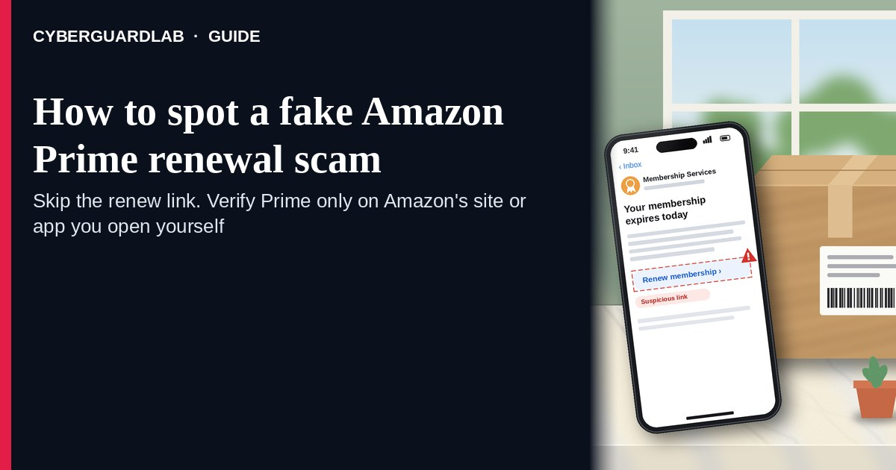
A fake Amazon Prime renewal scam is an unexpected email, SMS, or push-style message that claims your Prime membership “expires today,” that Amazon charged an unusual amount, or that you must “confirm billing” through a link. Real Amazon billing lives inside the account you open yourself — not inside a cold renew / pay / dispute link. The FTC’s phishing guidance is clear: do not click links or open attachments in unexpected messages; if you think a charge or membership notice might be real, go to the company using a website or app you know is real. Type amazon.com yourself, or open the official Amazon app already on your phone. This lure is different from an account already taken over and from a fake Amazon customer service phone call. CyberGuardLab is independent. Referral fees may affect product placement on other pages. Buying nothing and sticking to free verification habits is a valid outcome.

The short answer
Ignore the renew / dispute link in an unexpected “Prime expires” or “unusual Amazon charge” message; verify only at amazon.com or the official Amazon app you open yourself; never enter your Amazon password or card on a cold page.
Paid link
Norton 360 | See the Norton first-year offer

See the Norton first-year offer
Offer page: https://cyberguardlab.com/norton
Ad link: https://trysecurities.com/offer/norton?dtm=gg&cid=

What a fake Prime renewal usually looks like
Scammers copy Amazon membership language: “Prime ends in 24 hours,” “membership suspended,” “unauthorized charge — cancel now,” or “update your payment method.” The job is credential theft, card theft, or both.
Common shapes US households report:
- Email claiming Prime is about to expire with a bright “Renew now” or “Keep your benefits” button that does not land on amazon.com.
- SMS or iMessage about an “unusual Prime charge” with a short link to “view invoice,” “dispute,” or “cancel before tomorrow.”
- Look-alike Amazon login page after you tap — then your email, password, and often a one-time code harvest.
- Fake order / refund / membership receipt that mixes real-looking order IDs with a “manage billing” link outside Amazon.
- Follow-up after any reply or tap — once you engage, expect more “support” emails or a scripted call. Related renewal-style lure: Fake Microsoft 365 renewal scam.
FTC phishing guidance: do not click links in unexpected messages; if you think it might be real, contact the company with a website or phone number you know is real; report at ReportFraud.ftc.gov.
We do not claim Amazon “never emails about Prime.” Amazon may send real membership and receipt notices. The safe habit is always the same: leave the unexpected message, open amazon.com or the official app yourself, and manage Prime only inside a session you started.

Fake Prime renewal vs real Amazon notice vs related Amazon scams
Signal | Fake Prime renewal / charge message | Real Amazon membership notice (typical) | Related Amazon account or CS scam
Opening hook | “Prime expires today — renew / unusual charge — cancel now.” | Membership or receipt details you can also see after you sign into Amazon yourself. | “Your account is locked” takeover panic, or a cold “Amazon support” call.
Ask | Cold link, password on a look-alike page, card “to keep Prime.” | Usually none inside the message — manage billing inside the signed-in Amazon account. | Remote access, gift cards, or passwords on a cold call / fake support chat.
Pressure | Same-day loss of benefits, “final notice,” refund countdown. | Normal billing calendar; you verify on your schedule. | Immediate account lock or “refund agent” urgency.
Safe next step | Ignore link. Type amazon.com or open the official app. | Confirm membership and payment methods only inside Amazon Account. | See account-hacked and fake-CS guides; never trust cold callers.
Related guide | This page | amazon.com typed by you / official app | Account hacked — first hour · Fake Amazon CS call
If the page after the tap asks for your Amazon password plus a card or one-time code, stop — that is credential theft dressed as a Prime bill.

How to verify a Prime renewal message (US household steps)
Do this when any unexpected Prime expire / renew / unusual-charge message appears. You do not need a paid product to finish these steps.
- Do not tap the link, reply YES/NO, or call a number that lives only inside the message. Close the email or text. Do not discuss the “charge” with a caller who contacted you first.
- Open Amazon the way you already trust. Type amazon.com yourself, use a bookmark you saved earlier, or open the official Amazon app already on your phone — not the renew / dispute link.
- Check membership and payment methods only inside a signed-in session you started. Look at Account → Memberships / Prime / Payment methods. If nothing unexpected appears, treat the message as spam.
- Never enter your Amazon password, card, or one-time code on a page that arrived from a cold email or text. Legitimate Amazon account work does not require you to trust an unexpected shortener or look-alike domain.
- If you already tapped, typed a password, or entered a card, treat the first hour as incident response. Change your Amazon password from a session you started; turn on 2FA if it was off; call the number on the back of your card to watch for fraud. Follow Clicked a phishing link — first hour. If the account already shows unknown orders or address changes, use Amazon account hacked — first hour. Report at ReportFraud.ftc.gov; if identity data was stolen, use IdentityTheft.gov.
- Report the message and tell the household. Mark the email as phishing / junk; forward scam texts to 7726 (SPAM); file at ReportFraud.ftc.gov. Agree that nobody renews Prime, disputes Amazon charges, or “keeps benefits” from unexpected links. Checklist: How to report a scam to the FTC.

Signs the message is fake or unsafe (scan table)
Use this as a quick pass before you spend money or time.
Sign | Why it matters | What to do
Renew / cancel / dispute link lives only inside the unexpected message | Password and card theft | Ignore; open amazon.com or the official app
URL is a shortener, misspelled amazon name, or random form host | Phishing page | Never tap; type amazon.com
Urgent “Prime ends in 2 hours” or “refund only if you confirm today” | Fear used to skip verification | Slow down; check membership inside Amazon
Sender address is not an Amazon domain you recognize, or reply-to looks odd | Easy to spoof display names | Verify only inside a session you start
Page asks for Amazon password plus card / OTP on the same cold form | Credential + payment harvest | Stop; change password from official Amazon if you typed anything
You already replied, tapped, or spoke to a “billing agent” | Follow-up spam, malware, or account takeover risk | Stop engaging; verify on amazon.com; run first-hour steps if you entered secrets

Free habits that reduce the blast radius
You do not need a new subscription to lower damage if a fake Prime renewal gets through.
- Bookmark amazon.com (or keep only the official app); manage Prime only there.
- Household rule: never use renew / cancel / dispute links inside unexpected Amazon emails or texts.
- Strong unique passwords + 2FA on email and Amazon limit what a stolen password can unlock.
- Forward obvious scam texts to 7726; enable carrier and mailbox spam filtering when available.
- Optional antivirus / web filtering is a separate layer after a bad tap; it does not replace the verify-on-amazon.com habit.

What this page is not
This page is not a guide to canceling a real Prime membership, not a review of Amazon pricing, and not legal advice about a specific charge dispute.
It does not claim CyberGuardLab lab scores or “#1 anti-phishing” ranks. It does not tell you to ignore a real membership change you can also see inside your signed-in Amazon account — it tells you to verify there, not in the cold message. Official recovery and reporting stay with Amazon account security, your card issuer, ReportFraud.ftc.gov, and IdentityTheft.gov if personal data was stolen.

If you decide a paid extra is a real job
Most households can handle fake Prime renewal messages with the free steps above. Open a paid page only if you already named a job — for example broader web filtering, cross-device AV, or identity alerts after you gave a scammer personal data — and you will actually use it.
- PC / Mac suite with phishing and web protections many households already compare: Norton plans (paid link; confirm renewal price).
- Independent-test–oriented suite option: Bitdefender plans (paid link).
- Household suite shopping starting point: TotalAV plans (paid link; confirm renewal).
- Multi-device bill under one vendor: McAfee plans (paid link; confirm device limit).
- Another suite path some homes already use: Avast plans (paid link).
Buying nothing beyond free official-site verification habits is still valid. Paid links above are on-site only.

FAQ

Does Amazon really email or text about Prime renewals?
Amazon may send real membership and receipt notices. That is why the safe test is not “Amazon never messages,” but “I only manage Prime inside amazon.com or the official app I open myself.”

The message shows my name or part of an order number. Is that enough?
No. Names and order-like strings are easy to reuse from breaches, prior purchases, or guesswork. Trust the signed-in Amazon session you start yourself, not the message chrome.

I already entered my Amazon password on the renew page. What should I do first?
Change your Amazon password from amazon.com or the official app you open. Turn on 2FA if it was off. Watch email and payment methods for changes. Follow Clicked a phishing link — first hour. Report at ReportFraud.ftc.gov.

How is this different from a fake Amazon customer service call?
This page is about unexpected renew / charge links (email or text). The fake Amazon CS call guide covers cold phone “agents” pushing remote access or refunds. Same brand costume, different channel.

How do I report a fake Prime renewal scam?
Mark the email as phishing / junk, forward scam texts to 7726 (SPAM), and file at ReportFraud.ftc.gov. Steps for the FTC side are in How to report a scam to the FTC.

Do I need paid antivirus to spot these messages?
No. Spotting is a verification habit: ignore the link, open amazon.com or the official app, never enter secrets on a cold page. Antivirus can be a separate optional layer for malware after a bad tap; it does not replace that habit.

Sources
- How To Recognize and Avoid Phishing Scams (FTC)
- How to Recognize and Report Spam Text Messages (FTC)
- ReportFraud.ftc.gov
- IdentityTheft.gov
- Avoiding Social Engineering and Phishing Attacks (CISA)

Also read
- Amazon account hacked — first hour
- Fake Amazon customer service call
- Fake Microsoft 365 renewal scam
- Package holding fee scam

