
How to spot a fake airline customer service message
https://cyberguardlab.com/blog/airline-customer-service-impersonation-scam
Independent US household comparison site. Not the vendor. Paid links below may earn a commission. Confirm first-year price, renewal, device limit, and refund terms at checkout.
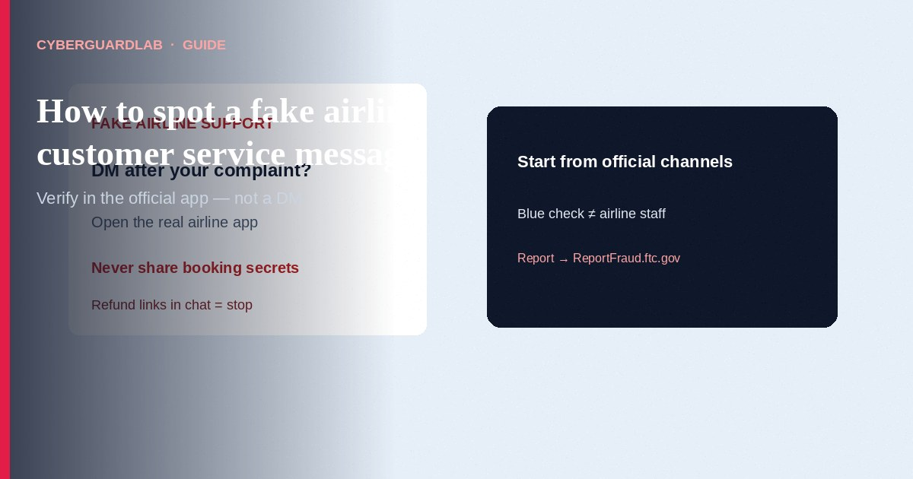
A fake airline customer service message is when someone pretends to be your airline—on social media, by email, text, or chat—and asks for booking details, payment info, or a login so they can “help” with a delay, cancellation, or refund. The FTC warns that scammers watch upset traveler posts, then reach out from look-alike accounts and push people toward spoofed sites. This guide covers airline customer service impersonation (social DMs, fake refund/cancellation notices, “agent” chats). It is not a vacation-rental booking guide and not a general password-reset phishing overview.

How the airline impersonation scam usually works
- Social media bait — You post about a delay or cancellation. A fake “airline support” account replies and offers to rebook or refund.
- Ask for booking or bank details — Scammers request confirmation numbers, phone numbers, bank account data, or other personal information.
- Spoofed help site — They send a link that looks like the airline’s site to harvest logins or card numbers.
- Urgent “act now” pressure — They claim the refund window closes soon, your seat will be lost, or you must verify payment immediately.
- Unofficial contact path — Real help starts from the airline’s own app, website, airport desk, or official social page linked from the airline’s site—not from a stranger who messaged you first.

Red flags before you share travel details
Cue | Safer habit | Scam signal
Paid link
Norton 360 | See the Norton first-year offer

See the Norton first-year offer
Offer page: https://cyberguardlab.com/norton
Who contacted you | You opened the official airline app/site or spoke to staff at the airport | A DM, email, or text that reached out after your public complaint
Where you verify the account | Official social page linked from the airline’s website; verification badge is helpful but not enough alone | Look-alike handle, new account, or “support” that only exists in DMs
What they ask for | Nothing sensitive in a public thread; you manage the booking inside your account | Confirmation number, bank details, passwords, one-time codes, or card CVV in chat
Links | You type the airline site yourself or use the installed app | “Click here to rebook/refund” from an unexpected message
Pressure | You can pause and check FlightRights.gov for real passenger rights | Pay fee / verify now / don’t hang up / don’t tell family

Steps: what to do when “airline support” messages you
- Pause — Do not click links, share confirmation codes, passwords, one-time codes, or bank details in that thread.
- Open the real channel yourself — Use the airline’s official app, website chat/phone listed on the site you typed, or talk to staff in person at the airport.
- Check the booking in your account — Confirm whether a real cancellation, rebooking, or refund status appears there. Treat a message-only claim with skepticism.
- If you use social media — Find the airline’s official page from the airline’s website first. Never give personal information on social media, per FTC guidance.
- Ignore look-alike agents who messaged you first — Real airlines do not need your bank account or login OTP to “unlock” a refund in a DM.
- If you already shared data — Change the airline (and related) password from the official site/app, turn on two-factor authentication where available, watch cards/bank statements, and start recovery at IdentityTheft.gov if personal information was stolen.
- Report — File at ReportFraud.ftc.gov. For unfair treatment by a real airline (not the scammer), see FlightRights.gov.

Safer travel-support habits (buy-nothing)
- Prefer the installed airline app or a URL you type yourself over links in unexpected messages.
- Keep booking confirmations offline or in your email; do not paste full details into public posts.
- Family rule: no “refund fees” paid by gift card, wire, crypto, or payment app.
- Microsoft Defender (or built-in OS protections) helps if the risk was a phishing page, but the main defense is refusing unexpected “support” asks. Paid suites are optional.

FAQ

Is every airline delay email a scam?
No. Airlines do send real schedule updates. Open the official app or site yourself and confirm the same change appears in your booking before you click anything in a message.

Someone DMed me after I complained on X/Facebook/Instagram. Could that be real?
The FTC describes this exact pattern as a common impersonation tactic. Start from the airline’s official channels instead of the DM that found you.

They already know my flight number. Does that mean they’re legit?
Not necessarily. Flight details are often public or easy to guess from a post. Still verify inside your account.

Where do I learn real passenger rights?
Use FlightRights.gov for DOT passenger protections and complaints about real airlines.

Do I need paid antivirus to avoid airline support scams?
No. Using official channels and refusing unexpected data asks is enough. Buy-nothing is valid.

If you still want a paid suite
Spotting a fake airline customer service message does not require paid antivirus. If you still want multi-device paid protection, use only these on-site links: Norton (paid link), Bitdefender (paid link), TotalAV (paid link), McAfee (paid link), Avast (paid link).

Extra caution
A blue check or airline logo in a DM does not prove the helper is real. Open the official app yourself, never share booking or payment secrets in social chat, and report imposters.

Sources
- FTC: Scammers impersonate airline customer service representatives
- FTC: How to avoid a scam
- FTC: What to do if you were scammed
- ReportFraud.ftc.gov
- IdentityTheft.gov
- FlightRights.gov (DOT passenger protections)

Also read
- Fake password-reset email
- Vacation rental scam
- Clicked a phishing link: first hour
- eBay seller impersonation scam
- Is Microsoft Defender enough?
- Report identity theft at IdentityTheft.gov

