
How to spot an AI voice clone family emergency scam
Read online: https://cyberguardlab.com/blog/ai-voice-clone-family-emergency-scam
Published October 12, 2026 · Updated October 12, 2026
Short answer
Hang up. Do not trust what you hear. Call the person who supposedly contacted you on a phone number you already know is theirs. If you cannot reach them, contact another family member or their friends and verify the story before you send anything. Never wire money, send cryptocurrency, or buy gift cards and share the card numbers and PINs for an unverified “emergency.” If you already paid or shared account access, try to reverse the transfer, tell your bank or app using a number from your statement, and report at ReportFraud.ftc.gov and IC3.gov.
Advertising disclosure: CyberGuardLab is an independent comparison site. We are not TotalAV, Norton, Bitdefender, McAfee, or Avast. If you buy through our links, we may earn a commission, which can affect ranking and placement.
Independent US household comparison site. Not the vendor. Paid links below may earn a commission. Confirm first-year price, renewal, device limit, and refund terms at checkout.
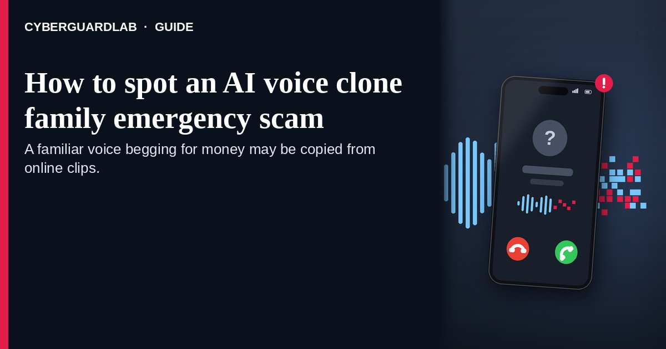
An AI voice clone family emergency scam is a phone call or voicemail that uses artificial-intelligence software to copy a relative’s voice, then claims that person is in a crisis and needs money right away — usually by wire, cryptocurrency, or gift-card numbers and PINs. The Federal Trade Commission’s March 2023 consumer alert explains that a short recording taken from online content plus a cloning program can make the caller sound like your loved one. The FBI’s December 2024 IC3 public service announcement warns about the same tactic. This page is about phone calls and voicemails that rely on a copied voice to ask for money. Calls with a fake face are covered separately in this site’s guide to fake video calls. CyberGuardLab publishes independent consumer guides. Elsewhere on the site some product pages may earn referral fees that can shape which products appear. Every step below is free; paid software is optional and shows up only at the end.

The short answer
Hang up. Do not trust what you hear. Call the person who supposedly contacted you on a phone number you already know is theirs. If you cannot reach them, contact another family member or their friends and verify the story before you send anything. Never wire money, send cryptocurrency, or buy gift cards and share the card numbers and PINs for an unverified “emergency.” If you already paid or shared account access, try to reverse the transfer, tell your bank or app using a number from your statement, and report at ReportFraud.ftc.gov and IC3.gov.
Paid link
Norton 360 | See the Norton first-year offer

See the Norton first-year offer
Offer page: https://cyberguardlab.com/norton
Ad link: https://trysecurities.com/offer/norton?dtm=gg&cid=

How an AI voice clone family emergency scam works
Official FTC, FBI, and FCC pages describe a few steps specific to this trick:
- The raw material is a recording you or your kids already published. The FTC’s March 2023 alert says a scammer may need only a short audio clip of your family member’s voice — often from content posted online — plus a voice-cloning program. Public social posts where someone speaks are the easiest source.
- Software turns that sample into new sentences. The FBI’s December 2024 PSA (alert I-120324-PSA) says criminals generate short clips to impersonate a close relative in a crisis situation, asking for immediate financial assistance or demanding a ransom.
- Short clips beat long conversations. Because the fake recording is brief, many attempts arrive as a voicemail or a few panicked seconds before someone else takes the phone. A recording cannot answer your follow-up questions, so the script tries to make you act on the recording alone.
- The pitch is built to stop a callback. The FTC’s April 2024 alert describes a scammer who copies a family member, calls pretending they need help, and asks you to send money right away. Speed is the point: one call to a saved number would end it.
- Payment is chosen so it cannot be pulled back. The FTC’s March 2023 alert flags wire transfers, cryptocurrency, and gift-card numbers and PINs. The FBI’s PSA says not to send money, gift cards, cryptocurrency, or other assets to people you know only over the phone.
- Regulators treat synthetic speech on robocalls as “artificial.” In Declaratory Ruling FCC-24-17 (adopted Feb 2, released Feb 8, 2024), the FCC confirmed that the Telephone Consumer Protection Act (TCPA) limits on an “artificial or prerecorded voice” cover current AI technologies that generate human voices. Such calls need the called party’s prior express consent. That ruling targets robocalls; it does not make a single personal scam call safe to trust.

Fake copied caller vs real call from family vs what a callback to a saved number reveals
Signal | Fake copied caller | Real call from family | What a callback to a saved number reveals
How it arrives | Unknown or blocked number, or a short voicemail with no way to reply in kind | Usually their own phone, or someone you can reach again | The real person picks up, or their phone rings normally with no sign of crisis
Identity “proof” | Only that it matches how they talk | They answer personal questions and the family code word without stalling | Whether the person you saved in contacts knows anything about the call
What they ask | Immediate wire, crypto, gift-card PINs, or another payment that cannot be reversed | Help that can wait a few minutes while you check | Usually no ask at all — the money request disappears once the real person is on the line
Safe next step | Hang up; do not call back the number that called you | Still confirm on a saved number before paying | If nobody answers, try a second saved contact before doing anything else

How to spot an AI voice clone family emergency scam
Use these free checks before you send money or share account details.
- Do not treat a familiar sound as proof. The FTC’s March 2023 alert tells you not to trust the voice alone. A close match is the lure, not evidence.
- Hang up and call back on a number you know is theirs. Both the March 2023 and April 2024 FTC alerts say to call the person who supposedly contacted you using a phone number you know is theirs, and verify the story. Do not use a number the caller just gave you.
- If you cannot reach them, contact another family member or their friends. The same FTC guidance says to try another relative or friends when the first callback fails. A real crisis can survive a second confirmation; a fake one often collapses when someone else answers. The same callback habit protects older relatives targeted by the grandparent emergency money scam.
- Refuse wire, crypto, and gift-card PIN asks until the story is verified. The FTC’s March 2023 alert treats those payment methods as red flags. The FBI’s December 2024 PSA says not to send money, gift cards, cryptocurrency, or other assets to unverified callers. Related checklists: gift card scam, wire transfer romance / advance-fee scam, and Zelle / Cash App payment scam.
- Use a family code word or phrase — and treat a miss as a stop sign. The FBI’s PSA recommends creating a secret word or phrase with your family to verify identity. Ask for it on the call. If the caller cannot give it, or pressures you to skip it, end the call and verify offline.
- Report the attempt even if you hung up early. File at ReportFraud.ftc.gov (How to report a scam to the FTC). The FBI asks victims of financial fraud schemes to report at IC3.gov and, when possible, to include caller details, payment data, and how contact started. Reporting helps even when no money moved.

Signs the caller is a fake copy (quick check)
Sign | Why it matters | What to do
Someone who posts spoken clips publicly suddenly needs cash | FTC March 2023: a short online clip plus cloning software can recreate it | Hang up and dial the number saved in your contacts
Only a voicemail, with a callback number you have never seen | A recording cannot be questioned; the new number is the scammer’s line | Ignore the left number; use the saved one
Payment must be wire, cryptocurrency, or gift-card numbers/PINs | FTC March 2023 flags those methods; FBI PSA says not to send them to unverified callers | Do not pay; see gift-card and wire guides if you already did
No answer to your family code word or phrase | FBI PSA: create a secret word/phrase to verify identity | End the call; reach the real person another way
Tone or word choice that does not fit how they really talk | FBI PSA: listen closely to the tone and word choice to tell a real call from vocal cloning | Useful clue, not a requirement — still verify by callback

Free habits that shrink the risk
None of these needs a subscription.
- Agree on a family code word or phrase ahead of time (FBI IC3 advice) and practice using it when someone asks for money under stress.
- Make social accounts private, limit followers to people you know, and keep spoken clips of household members off public posts. The FTC notes scammers pull short clips from online content; the FBI advises limiting online content of your image or voice.
- Save real mobile numbers for close relatives in your contacts so a callback never depends on a number read to you on a panic call.
- Household rule: nobody wires money, buys gift cards for a stranger, or sends crypto because a caller seemed familiar. Gift-card pressure is its own family — see the gift-card guide linked in the how-to steps above.
- Keep email and banking behind unique passwords in a password manager, with multi-factor authentication on (Password manager setup for a US household · Turn on 2FA for Gmail, Apple, and your bank).
- If a voicemail leaves a new number to call, write it down with the date and time for your report, then dial the contact you already had. Do not press any key or reply by text first.
- Bookmark ReportFraud.ftc.gov and IC3.gov yourself so a panicked caller never becomes your reporting channel.

What this page is not
This guide covers one audio pattern: a phone call or voicemail that uses an AI-cloned voice of someone close to you to demand urgent money.
This page covers spotting the copied caller on the line itself. For the broader money-request script aimed at grandparents, see the grandparent emergency money scam guide. It is not a deepfake video call scam (a separate channel), not a romance scam or long-game pig-butchering relationship, not government impersonation, and not a tech support scam phone call. Payment-method pages such as gift card scam, wire transfer romance / advance-fee scam, and Zelle / Cash App payment scam explain how those channels work once money is in play; How to report a scam to the FTC is the filing walkthrough. We are not saying every distressed call from family is criminal, and we are not giving legal advice beyond what the cited FTC, FCC, and FBI pages publish.

If you want an optional paid layer
Stopping a copied-caller money call is mostly a verification habit: hang up, call a number you already trust, use a family code word, and never send hard-to-reverse payments first. Free reporting and bank follow-up cover the urgent part. Paid tools are optional extras — for example malware scanning if a follow-up text pushed you to open a link, or identity monitoring after you shared personal details. Compare only when you already want that layer:
- Norton plans: look at device protection tiers that also bundle identity tools on some plans (paid link; check renewal pricing before you buy).
- Bitdefender plans: useful to compare if you care about independent lab rankings more than brand familiarity (paid link).
- TotalAV plans: a multi-device household option to price against other suites (paid link; confirm what renews).
- McAfee plans: one subscription covering several devices for households that want a single bill (paid link; check the device cap).
- Avast plans: another suite some homes already run and may prefer to keep (paid link).
You can skip every paid option. These links stay on this site only.

FAQ

Can scammers really copy how my child talks on the phone?
Yes. The FTC’s March 2023 alert says a short clip — often taken from content posted online — and a cloning program can be enough to copy them.

What should I do the moment a familiar caller begs for money?
Hang up. Call that person back on a phone number you already know is theirs. If you cannot reach them, contact another family member or their friends and verify before you send money. That is the FTC’s core advice in both the 2023 and 2024 alerts.

Is wiring money, sending crypto, or buying gift cards ever okay on that call?
Not until you have verified the story offline. The FTC flags wire, cryptocurrency, and gift-card numbers/PINs as scam signs. The FBI says not to send money, gift cards, crypto, or other assets to unverified callers.

Should our family set up a code word?
Yes. The FBI’s December 2024 PSA recommends creating a secret word or phrase with your family to verify identity. Agree on it when everyone is calm, and treat a wrong answer as a reason to hang up and call a known number.

What clues can I catch on a phone-only call or a voicemail?
Listen to tone and word choice, which the FBI’s December 2024 PSA names as clues. Notice whether the speaker can answer a follow-up question or only repeats a short plea. A voicemail that asks you to call an unfamiliar number is a reason to dial the saved one instead.

I already sent money or shared account details. What now?
Contact your bank, wire company, or payment app immediately using a number from your statement or the official app, and ask about reversing or freezing the transfer. Report at ReportFraud.ftc.gov and IC3.gov. If personal information was misused, start at IdentityTheft.gov (Report identity theft). Related payment checklists: gift card scam, wire transfer romance / advance-fee scam, and Zelle / Cash App payment scam.

Sources
- Scammers use AI to enhance their family emergency schemes (FTC Consumer Advice, Mar 20, 2023)
- Fighting back against harmful voice cloning (FTC Consumer Advice, Apr 8, 2024)
- Criminals Use Generative Artificial Intelligence to Facilitate Financial Fraud (FBI IC3 PSA, Dec 3, 2024)
- FCC confirms TCPA applies to AI technologies that generate human voices (FCC Declaratory Ruling FCC-24-17, released Feb 8, 2024)
- ReportFraud.ftc.gov
- IdentityTheft.gov
- Internet Crime Complaint Center (FBI IC3)

Also read
- Grandparent emergency money scams
- Fake friend emergency Facebook messages
- Romance scams online
- Report identity theft

